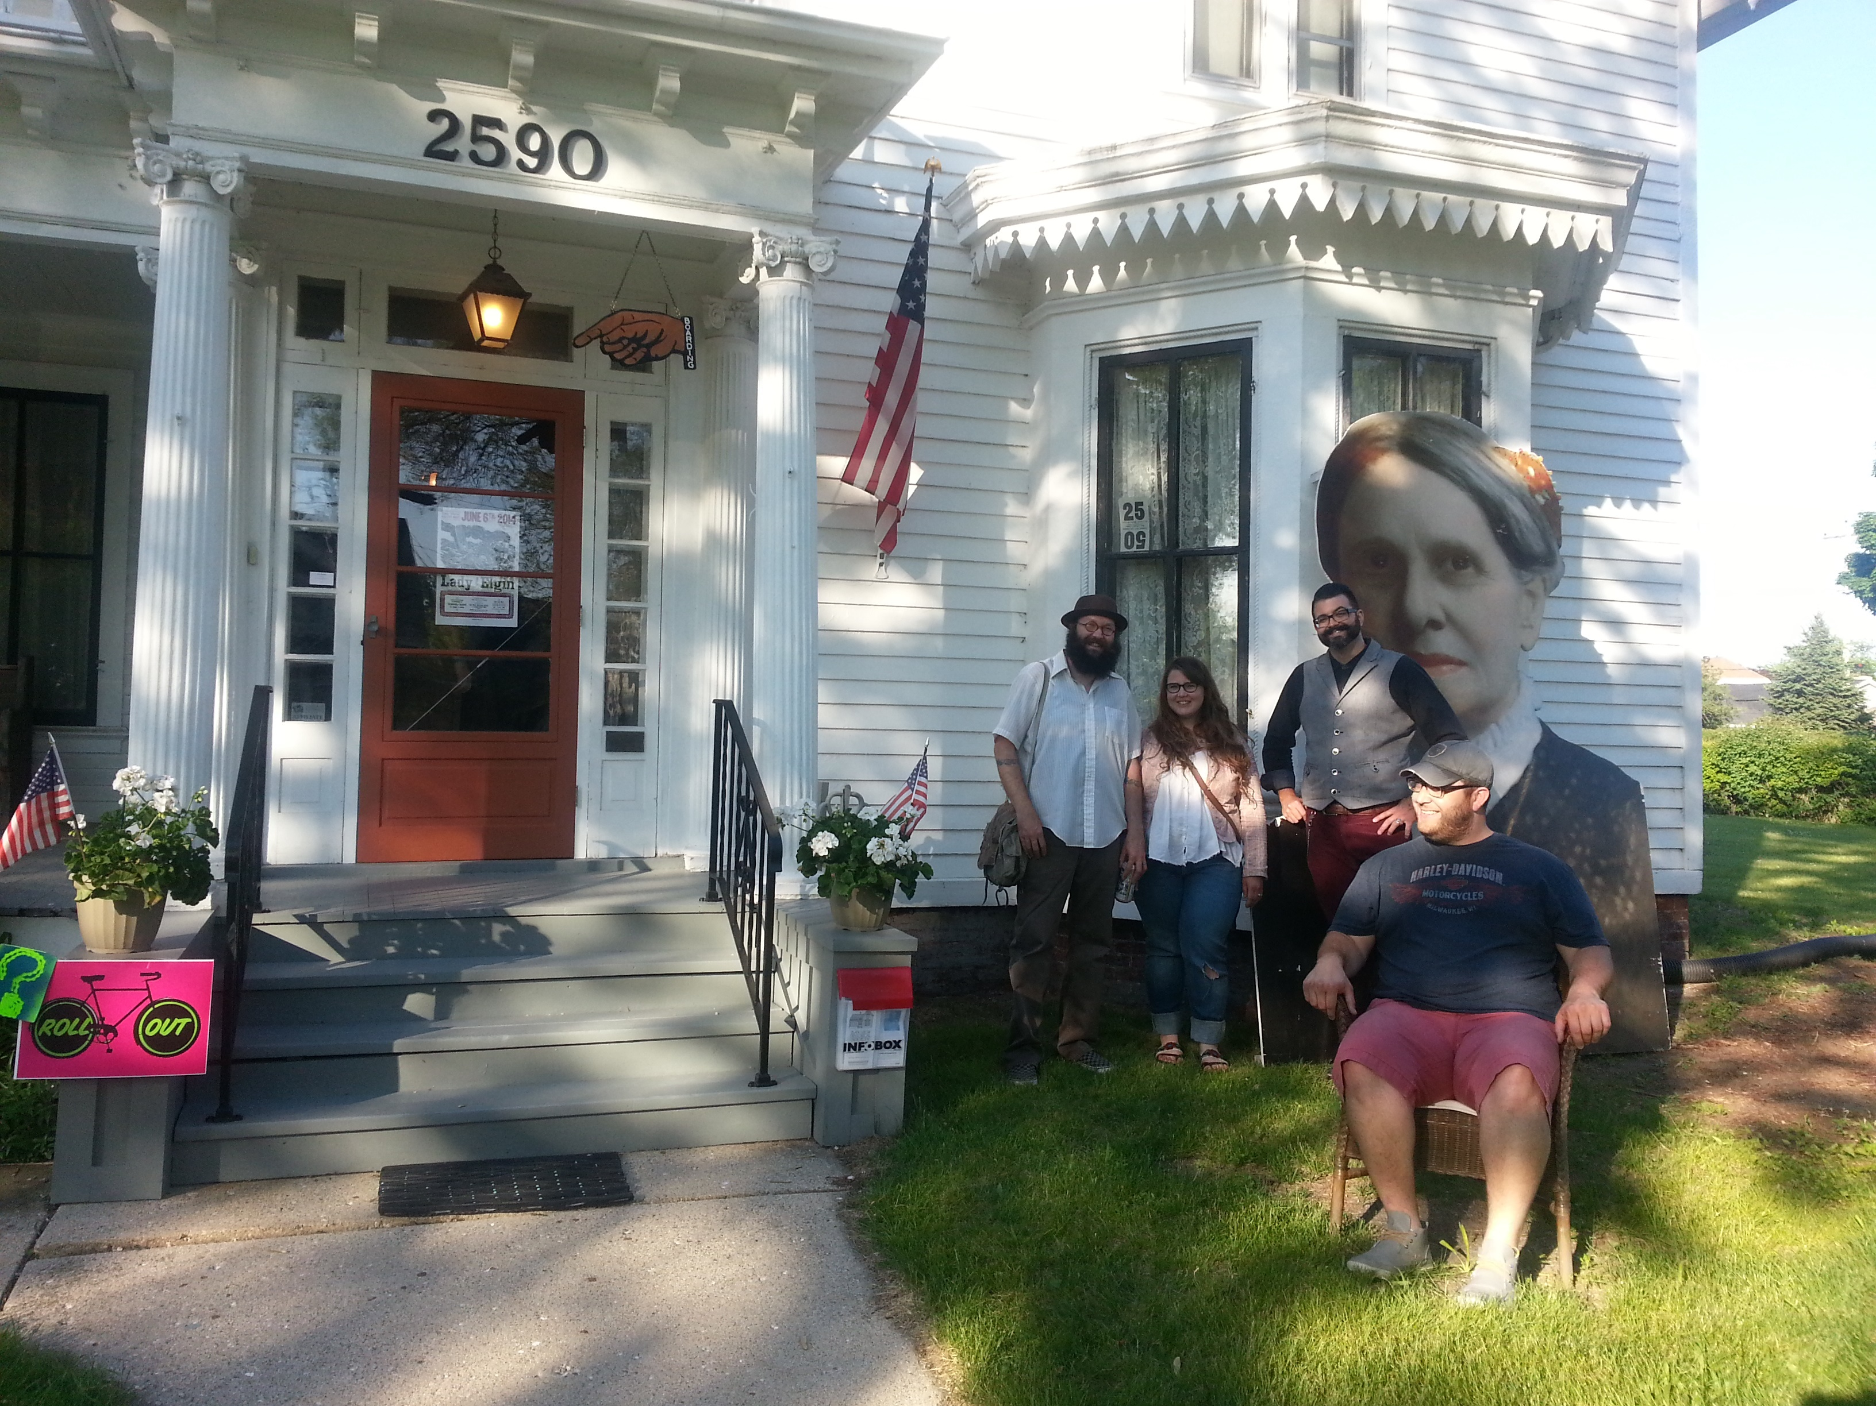  Bay View Gallery Night  Thanks to our wonderful members, friends and community we have:  Paid the mortgage and continue restoration of the historic Beulah Brinton House.  Increased membership and involvement in programs for our community.  Implemented projects for local schools to study history of the area with members.  Hosted art, music, and educational events.  Provided historic tours and landmark dedications.  Published HISTORIAN newsletter, with events and historical stories.  Collaborated with many community organizations to have a sense of belonging to Bay View. |  |  | Celebrating our 35th Anniversary  About Us  Bay View Historical Society was formed after the centennial celebration of Bay View by neighbors Paul Kohlbeck and Audrey Quincey in 1979. Many events initiated the society’s mission to ENCOURAGE A SENSE OF COMMUNITY BY PRESERVING, CELEBRATING, AND SHARING BAY VIEW’S RICH HERITAGE.  John Gurda wrote Bay View, WI about “a city within a city that has a strong community identity. There is a small town feeling here”.  Contact Us  Email: bayviewhistoricalsociety@gmail.com  Web: www.bayviewhistoricalsociety.org  Facebook: Bay View Historical Society  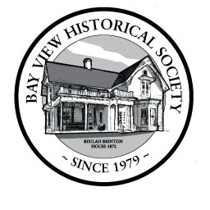 Bay view historical society 2590 S. Superior st Bay view, wi 53207 Bay view historical society 2590 S. Superior Street Bay View, WI 53207 |  |  | 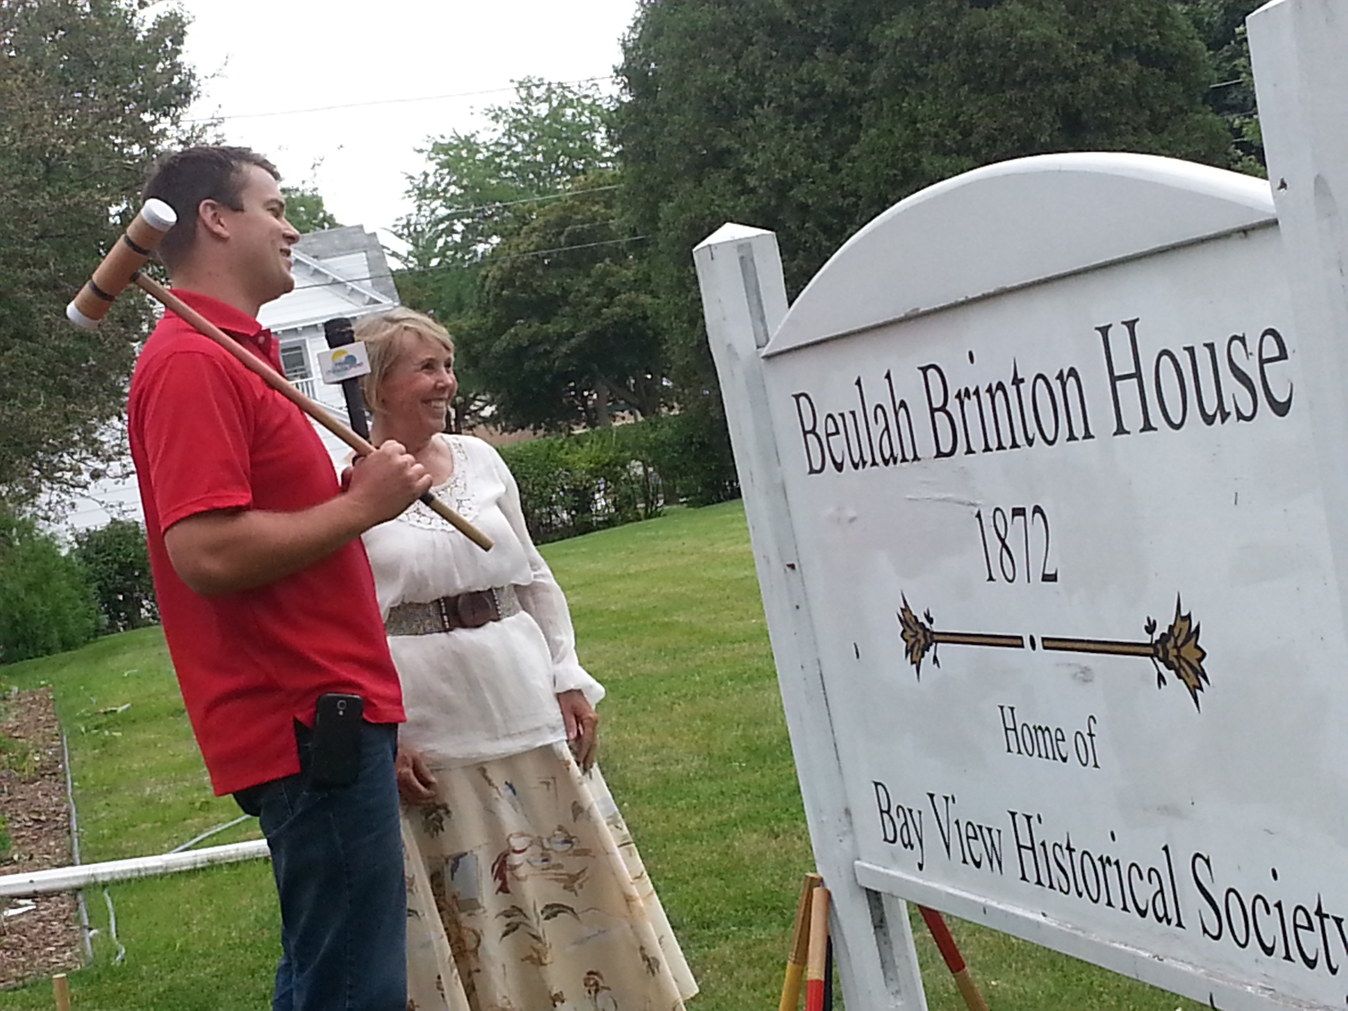  Bay view historical society  - Join us and celebrate 35 years August 28th and 29th 2015

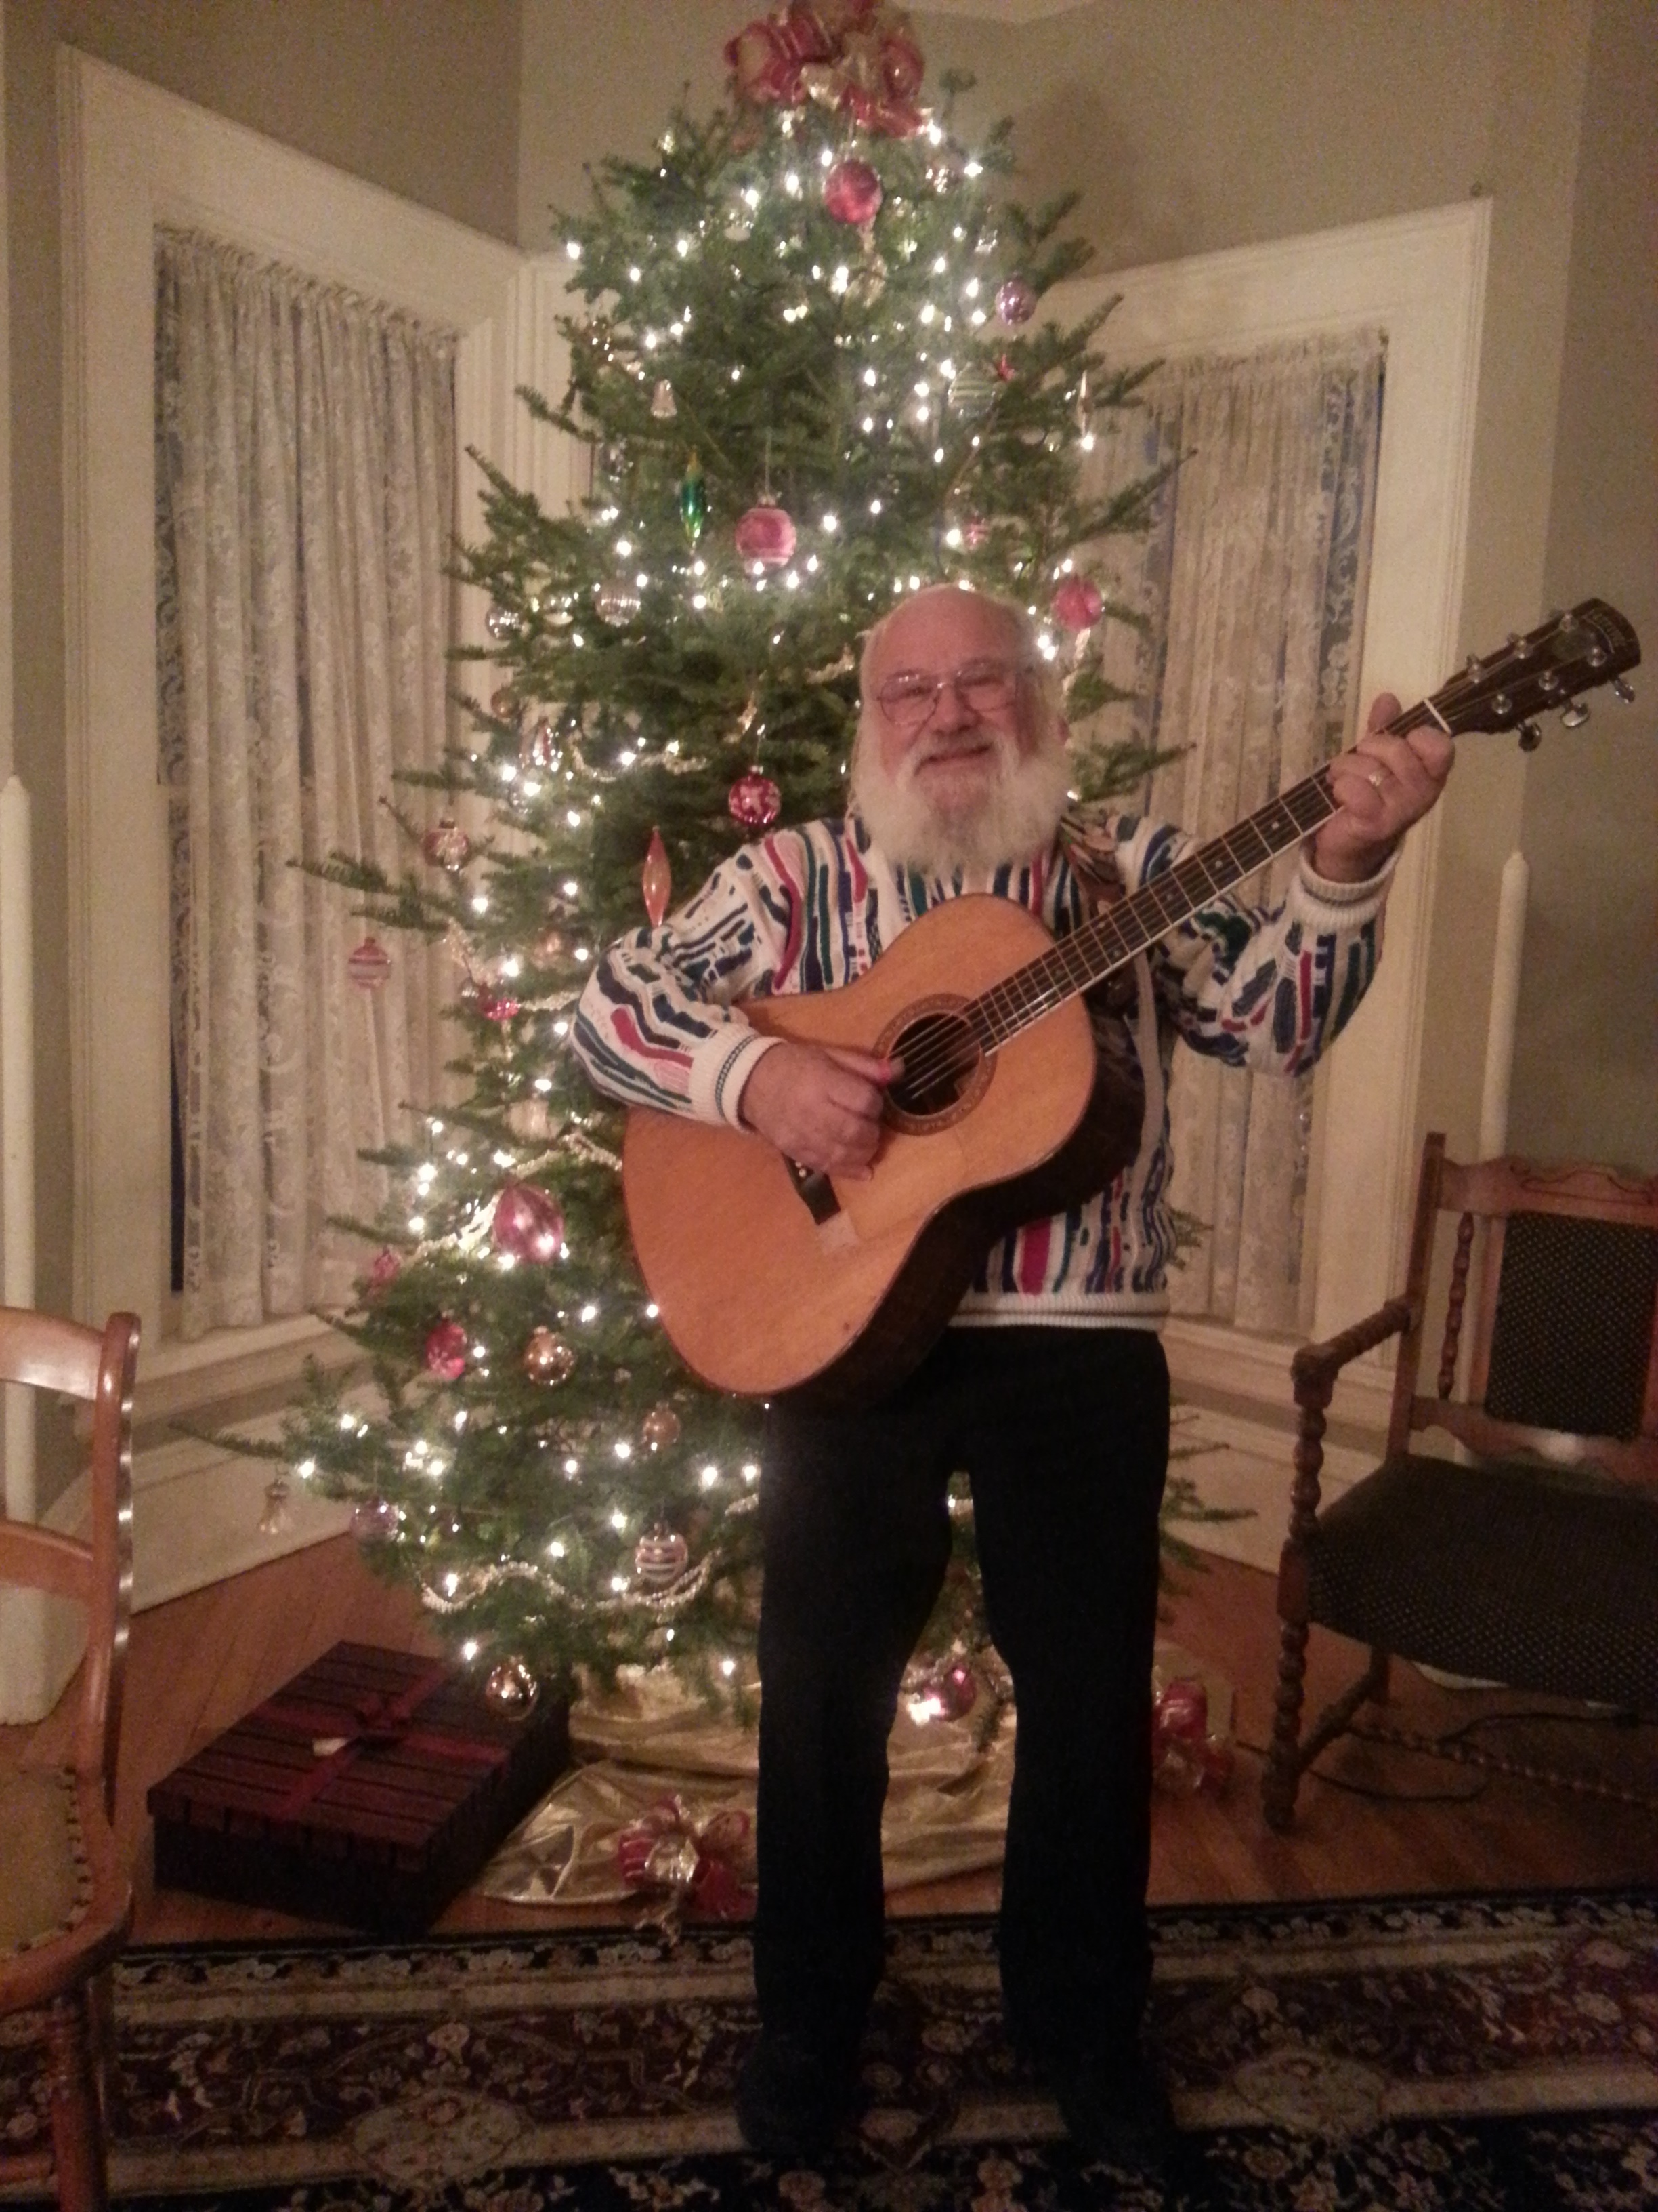  David Drake – Holiday Gathering  UPCOMING EVENTS:  Monthly Open House Tours: third Saturday every month at Beulah Brinton House  Annual Meeting and Program: Monday, Oct. 5th at Beulah Brinton House  Beulah Brinton House concert: Sunday, Nov. 29th Celebration of Larry Penn with Lil Rev and friends  Holiday Gathering: Saturday, Dec. 12th music, social and historic for the holidays at Beulah Brinton House! |  |  | August 28-29th CELEBRATION!  We’re planning something for every age and interest.  FRIDAY, Aug. 28th 5 -10 pm  HISTORIC PUB CRAWL- many local pubs will have drink and food specials. A self-guided tour and locations will be available on our website, facebook and in print.  JOIN US for the weekend of fun events. OPEN to the public. It’s our way to say thank you, Bay View!  Events throughout the day!!  SATURDAY, Aug. 29th  9 am – walking tour  Noon – 6 pm – lawn party, food and beverages, vintage hat collection, ice cream social, children’s activities and more . . .  6 – 8 pm – reception and musical performance by Robin Pluer.  Vintage attire is appropriate!!  Check our website for details:  www.bayviewhistoricalsociety.org | ! |  | 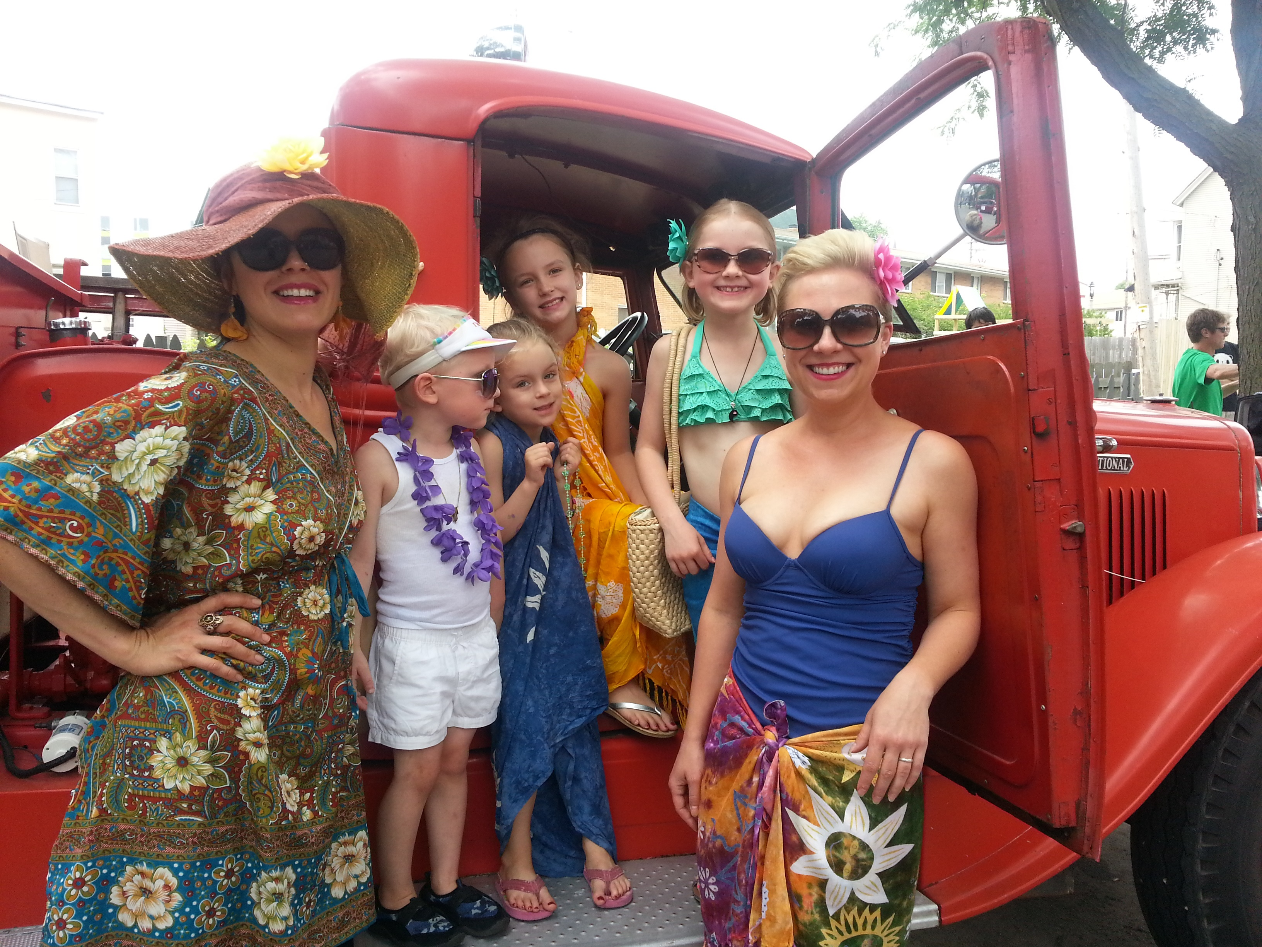  July 4th Parade -Humboldt Park  Members enjoy benefits:  Access to historical archives and research  Activities for families and kids  Community events: Gallery Nights, Doors Open, Avalon Theater, BV classic Bike Race, BV Music Festival, SS Frolics, Farmer’s Market, 4th of July Parade and celebrations  Discounts and specials from local businesses  Historic Beulah Brinton House as our home  Opportunities to learn and be fascinated with local history  Programs and experiences with many interesting people and places  Volunteering and connection to a community that cares

